**Web Technology for bioinformatics**

Name - Dharineesh K S Date - 16/10/2021

Regno - 123013012 Ex.no - 04

**Aim:**

To build a part of the search page from the webpage http://scbt.sastra.edu/mutbrowser/ ,which is used to access mutation information from a database containing different mutation properties, using PHP.

**Dataset Information:**

Amyotrophic Lateral Sclerosis (ALS) is a commonly occurring fatal neurological disorder. It is of two types: familial ALS (fALS), which is hereditary and sporadic ALS (sALS) for which the cause is unknown. Recent research identified scattered mutations in Cu/Zn superoxide dismutase (SOD1), resulting in the accumulation of misfolded SOD1 over the motor neuron, as the primary cause of ALS.

Literature survey sourced 104 mutations in the SOD1 protein, but the causative mechanism of these mutations is still uncertain. Every mutated form of the protein was modelled using the Mutate & Solvate server.

Secondary structure and accessibility information was obtained for modelled proteins using the programs Stride and NAccess respectively.

Mutation-induced changes were calculated and their effects were analyzed based on definitive physiochemical, energetic and conformational properties of the amino acids shown in the table.

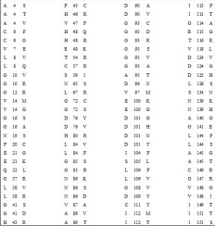

**Steps:**

**Download the SQL Data set from the Bioinformatics Intranet Server,** given the SQL database file(partial list) for Amyotrophic Lateral Sclerosis mutation data. Store that into the Mysql Database

Create 3 dropdowns showing the list of wild type residues, mutation position and the respective mutation residues. Upon selection in the drop down, respective mutation position is altered in the second list of items. When the second list of items altered, respective mutation positions are changed.

**Using PHP:**

Finally when the user submits the data in the server, all other information regarding that

mutation is parsed using PHP mysql.

**Code:**

**The code below is written in a PHP scripts:(input.php)**

**<?php**

**/\***

**Author : Dharineesh K S**

**Regno : 123013012**

**\*/**

**echo "**

**<!DOCTYPE html>**

**<head>**

**<title>select mutants</title>**

**<style type=\"text/css\">**

**body {**

**font-family: \"Times New Roman\";**

**background-color: #f2f2f2 ;**

**}**

**select{**

**background-color: white ;**

**padding : 2px 10px ;**

**}**

**</style>**

**</head> ";**

**echo"<body>";**

**$connection = mysqli_connect("localhost","root","")or die(mysql_error());**

**mysqli_select_db($connection,"mutdb")or die(mysql_error($connection));**

**echo "<h1 align=center>Mutationdb</h1>";**

**echo "<h4 align=center>Mutation browser for SODI mutants causing ALS</h4>";**

**echo "**

**<p>**

**The only cause known for the occurrence of ALS is mutation.**

**But it is complex to identify what effect these scattered mutations cause ALS.**

**To know about a mutation and the effect of that mutation on ALS causing mechanism,**

**select a mutation:**

**</p>";**

**echo "<br>";**

**echo "**

**<form method=post action='details.php'>";**

**$sql1 = "select distinct RESIDUES from mutdb";**

**$query1 = mysqli_query($connection,$sql1);**

**echo "**

**<table align=center cellpadding=5px>**

**<tr>**

**<th>Wildtype Residue</th>**

**<th>Mutation Position </th>**

**<th>Mutation Residue </th>**

**</tr>**

**";**

**echo "**

**<tr>**

**<td align=center>**

**<select name=wildres>**

**";**

**while ($row = mysqli_fetch_array($query1) )**

**{**

**$wild = $row['RESIDUES'];**

**echo "<option>$wild</option>";**

**}**

**echo "**

**</select>**

**</td>**

**";**

**$sql2 = "select distinct POSITION from mutdb";**

**$query2 = mysqli_query($connection,$sql2);**

**echo "**

**<td align=center>**

**<select name=mutpos>";**

**while ($row = mysqli_fetch_array($query2) )**

**{**

**$pos = $row['POSITION'];**

**echo "<option>$pos</option>";**

**}**

**echo "**

**</select>**

**</td>**

**";**

**$sql3 = "select distinct MUTATIONS from mutdb";**

**$query3 = mysqli_query($connection,$sql3);**

**echo "**

**<td align=center>**

**<select name=mutres>";**

**while ($row = mysqli_fetch_array($query3) )**

**{**

**$mut = $row['MUTATIONS'];**

**echo "<option>$mut</option>";**

**}**

**echo "</select></td></tr>";**

**echo "<tr>**

**<td></td>"; #empty column**

**echo "**

**<td align=center>**

**<input type =submit value= submit>**

**</td>";**

**echo "<td></td>";**

**echo "</table>";**

**echo "</form>";**

**echo "</html>";**

**?>**

**Output of input.php file:**

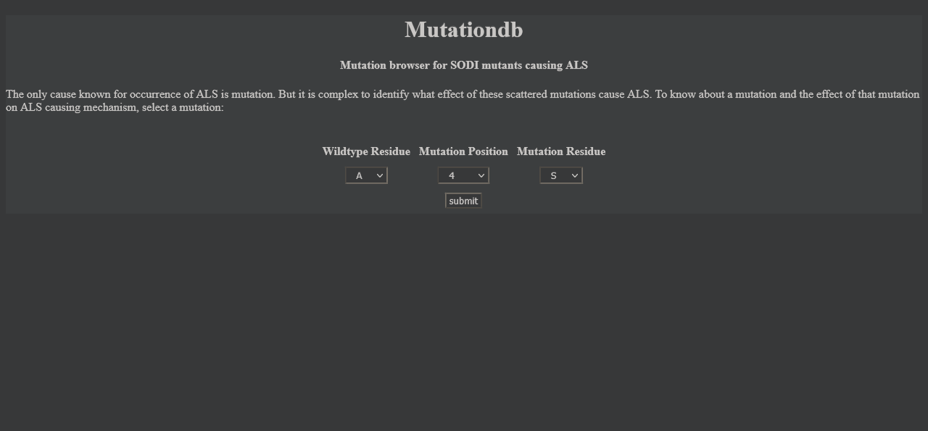

**The code below is written in a PHP scripts:(showdetails.php)**

**<?php**

**/\***

**Author : Dharineesh K S**

**Regno : 123013012**

**\*/**

**echo "**

**<!DOCTYPE html>**

**<head>**

**<title>MUTATIONS Details Report</title>**

**<style type=\"text/css\">**

**body {**

**font-family: \"Times New Roman\";**

**}**

**table{**

**width: 50%;**

**border-collapse: collapse;**

**}**

**tr:nth-child(even) {**

**background-color: #f2f2f2 ;**

**}**

**a{**

**text-decoration: none;**

**}**

**p{**

**color : red;**

**}**

**</style>**

**</head> ";**

**echo"<body>";**

**$connection = mysqli_connect("localhost","root","")or die(mysql_error());**

**mysqli_select_db($connection,"mutdb")or die(mysql_error($connection));**

**$wildres = $_POST['wildres'];**

**$pos = $_POST['mutpos'];**

**$mutres = $_POST['mutres'];**

**$sql = "select * from mutdb where POSITION=$pos and RESIDUES = '$wildres' and MUTATIONS = '$mutres'";**

**$query = mysqli_query($connection,$sql) or die(mysqli_error($connection));**

**$num = mysqli_num_rows($query);**

**if ($num == 0)**

**{**

**echo "Mutation details not available";**

**}**

**else {**

**while ($row = mysqli_fetch_array($query))**

**{**

**echo " <table align='center' cellpadding = 2px >";**

**$mutation = $row["MUTATIONS"];**

**$exon_no = $row["EXON_No"];**

**$class = $row["CLASS"];**

**$coverage = $row["DISTRIBUTION"];**

**$codon = $row["CODON_CHANGE"];**

**$onset = $row["ONSET"];**

**$stability = $row["STABILITY"];**

**$ref = $row["PUBMED"];**

**$struct = $row["RCSB"];**

**$exposure = $row["EXPOSURE"];**

**echo "<tr><td><p>Mutation:</p></td><td>$mutation</td></tr>";**

**echo "<tr><td><p>Exon number:</p></td><td>$exon_no</td></tr>";**

**echo "<tr><td><p>Class:</p></td><td>$class</td></tr>";**

**echo "<tr><td><p>Coverage:</p></td><td>$coverage</td></tr>";**

**echo "<tr><td><p>Codon change:</p></td><td>$codon</td></tr>";**

**echo "<tr><td><p>Onset:</p></td><td>$onset</td></tr>";**

**echo "<tr><td><p>Stability:</p></td><td>$stability</td></tr>";**

**echo "<tr><td><p>Reference:</p></td><td><a href='$ref' target='_blank'>$ref</a></td></tr>";**

**echo "<tr><td><p>Structure:</p></td><td>$struct</td></tr>";**

**echo "<tr><td><p>Exposure:</p></td><td>$exposure</td></tr>";**

**echo "</table>";**

**} }**

**echo"</body>";**

**echo"</html>";**

**?>**

**Output of showdetails.php :**

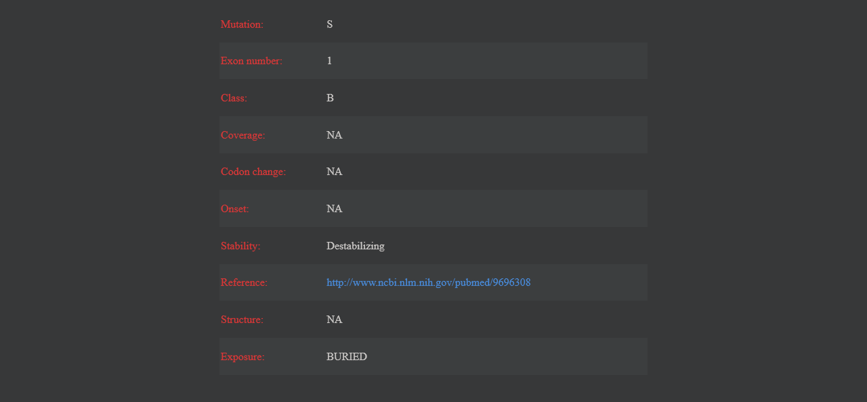

**Result:**

The mutation browser is successfully created.